1. **Data Persistence**: We have two approaches with their own advantages and disadvantages. So, we have a 3rd approach which is hybrid of the two.
2. 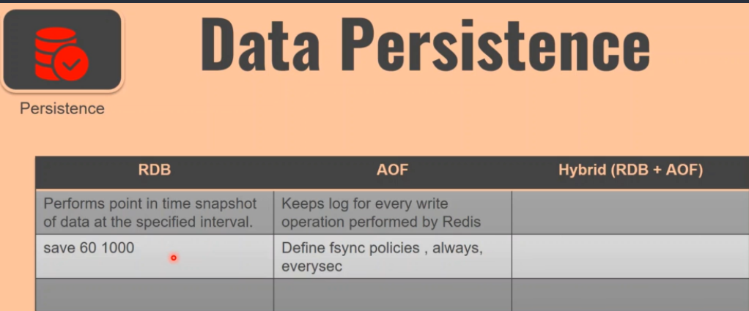
3. **How to use RDB** **(Redis Database Backup)🡺**Either use configuration file or give configuration on redis-cli console.
   1. In RDB, we perform **point-in-time snapshot** of the data which is available in REDIS.
   2. That means we define sort of **snapshoting policy**.
   3. During redis restart either from crash or normally, we can restore data from the saved point-in-time snapshot.
   4. **Snapshot Policy** 🡺 save 60 100 🡸 Every 60 seconds, if there are 1000 (insertions+updates+deletion), take a snapshot of the data.
   5. This is one configuration but you may have any number of configurations. Like
      1. Save 60 1000
      2. Save 1 10,0000
   6. In RDB, we don’t get **point of failure** in a data recovery but **point in time** data recovery.
   7. This is recovery mechanism from latest timestamp but the data after that timestamp will not be available.
4. **AOF**: **Append Only File**.
   1. In this approach, you just tell redis to take note of each modifying operation into some other file.
   2. During restart after crash or normal restart, all the logged commands are replayed.
   3. In AOF, we have something called 🡺 Define **fsynch policies**. So we can define how frequently we want to sync (We want to keep writing the logs).  
      Remember whatever the policies we define, is going to impact the performance as AOF file is on hard disk.
   4. In AOF, we can actually make it like almost **point of failure**, you can restore**.**

RDB (Redis Database Backup) Advantages and Disadvantages.

1. When we perform **RDB snapshotting**, Redis runs a **child process** which is called **FORK**.
2. These process snapshots all the redis data in a single RDB file which is called **RDB.dump**.
3. This is good if we want to perform any external backups. Let’s say very 24 hours.
4. 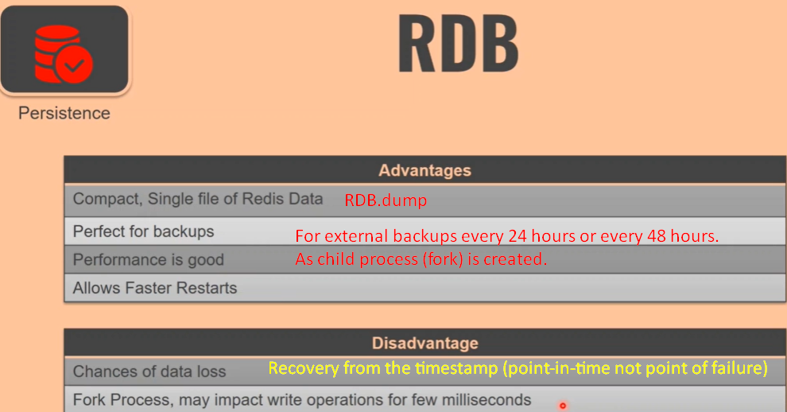

AOF(Append Only File) Advantages and Disadvantages.

1. 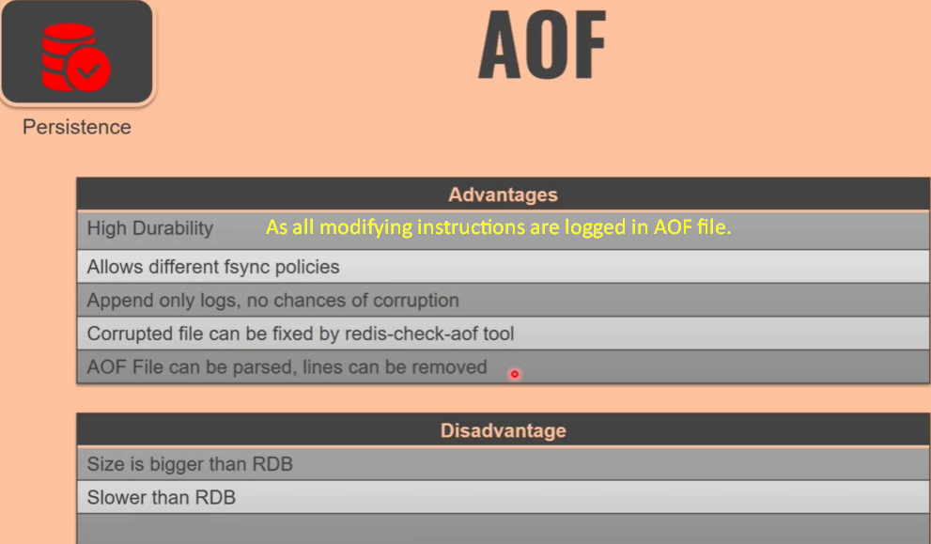  
   AOF File can be parsed, lines can be removed: If by mistake, you run flushall command which deletes all the key-value pairs from memory.   
   **Solution**: You can go to the AOF file and remove the flushall command as it would be logged in there and run the logged instructions in the AOF file.